PIZZA SALES SQL QUERIES

1) KPI’s

**1.Total Revenue**

select ROUND(SUM(total_price),2)as Total_Revenue from pizza_sales;

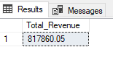

**2. Average Order Value**

select ROUND(SUM(total_price) / COUNT(DISTINCT order_id),2)as Avg_Order_Value from pizza_sales;

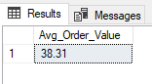

**3. Total Pizza Sold**

select SUM(quantity)as Total_Pizza_Sold from pizza_sales;

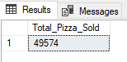

**4. Total Orders**

select COUNT(DISTINCT order_id)as Total_Orders from pizza_sales;

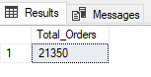

**5. Average Pizza’s Per Order**

select CAST(CAST(SUM(quantity) as DECIMAL(10,2)) /

CAST(COUNT(DISTINCT order_id)as DECIMAL(10,2))as DECIMAL(10,2))as Average_Pizzas_Per_Order from pizza_sales;

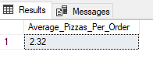

2) CHARTS

**1. Daily Trend for Total Orders**

select DATENAME(DW, order_date)as Order_Day, COUNT(DISTINCT order_id)as Total_Orders from pizza_sales group by DATENAME(DW, order_date);

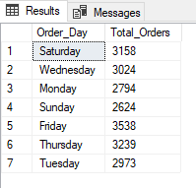

**2. Hourly Trend for Orders**

select DATEPART(HOUR,order_time)as Order_Hours,COUNT(DISTINCT order_id)as Total_Orders from pizza_sales

group by DATEPART(HOUR,order_time)

order by DATEPART(HOUR,order_time);

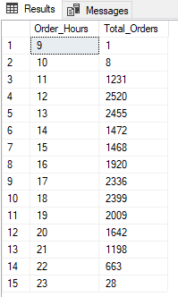

**2. Monthly Trend for Total Orders**

select DATENAME(MONTH, order_date)as Month_Name, COUNT(DISTINCT order_id)as Total_Orders from pizza_sales group by DATENAME(MONTH, order_date) order by Total_Orders DESC;

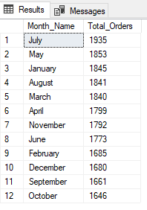

**3. Percentage of Sales by Pizza Category (For January)**

select pizza_category, ROUND(SUM(total_price),0)as Total_Sales, ROUND(SUM(total_price) * 100 / (select SUM(total_price) from pizza_sales where MONTH(order_date) = 1),2)as PCT

from pizza_sales

where MONTH(order_date) = 1

group by pizza_category;

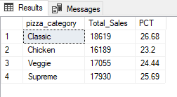

**4. Percentage of Sales by Pizza Size (For First Quarter)**

select pizza_size, ROUND(SUM(total_price),0)as Total_Sales, ROUND(SUM(total_price) * 100 / (select SUM(total_price) from pizza_sales where DATEPART(QUARTER, order_date) = 1),2)as PCT

from pizza_sales

where DATEPART(QUARTER, order_date) = 1

group by pizza_size

order by PCT DESC;

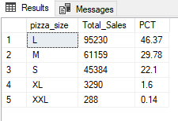

**5. Total Pizzas Sold by Pizza Category**

select pizza_category, SUM(quantity)as Pizza_Sold from pizza_sales group by pizza_category;

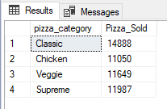

**6. Top 5 Best Sellers by Revenue, Total Quantity and Total Orders**

**i) by total revenue**

select TOP 5 pizza_name, SUM(total_price)as Total_Revenue from pizza_sales

group by pizza_name

order by Total_Revenue DESC;

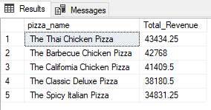

**ii) by total quantity**

select TOP 5 pizza_name, SUM(quantity)as Total_Quantity from pizza_sales

group by pizza_name

order by Total_Quantity DESC;

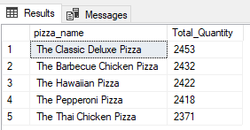

**iii) by total orders**

select TOP 5 pizza_name, COUNT(DISTINCT order_id)as Total_Orders from pizza_sales

group by pizza_name

order by Total_Orders DESC;

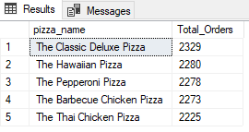

**7. Bottom 5 Sellers by Revenue, Total Quantity and Total Orders**

**i) by total revenue**

select TOP 5 pizza_name, SUM(total_price)as Total_Revenue from pizza_sales

group by pizza_name

order by Total_Revenue ASC;

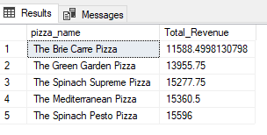

**ii) by total quantity**

select TOP 5 pizza_name, SUM(quantity)as Total_Quantity from pizza_sales

group by pizza_name

order by Total_Quantity ASC;

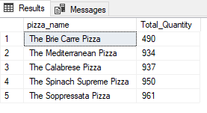

**iii) by total orders**

select TOP 5 pizza_name, COUNT(DISTINCT order_id)as Total_Orders from pizza_sales

group by pizza_name

order by Total_Orders ASC;

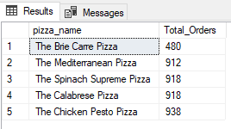

NOTE

If you want to apply the pizza_category or pizza_size filters to the above queries you can use WHERE clause.

SELECT Top 5 pizza_name, COUNT(DISTINCT order_id) AS Total_Orders

FROM pizza_sales

WHERE pizza_category = 'Classic'

GROUP BY pizza_name

ORDER BY Total_Orders ASC